**Year 11 Human Biological Science**

**Respiratory and Circulatory Systems**

Name: ____________________________________________

Multiple Choice Answer Sheet

1. A B C D 11. A B C D

2. A B C D 12. A B C D

3. A B C D 13. A B C D

4. A B C D 14. A B C D

5. A B C D 15. A B C D

6. A B C D 16. A B C D

7. A B C D 17. A B C D

8. A B C D 18. A B C D

9. A B C D 19. A B C D

10. A B C D 20. A B C D

**Year 11 Human Biological Science**

**Respiratory and Circulatory Systems**

Name: ____________________________________________

**PART A: Multiple Choice (20 marks)**

1. Blood carried in the pulmonary vein empties into which part of the heart?

a) Right atrium

b) Light ventricle

c) Left atrium

d) Left ventricle

2. What is the role of the chordinae tendonae?

a) They act as a portion of the skeleton of the heart, strengthening heart walls.

b) They keep the semilunar valves in position.

c) They keep the atrio-ventricular valves from opening in the wrong direction.

d) They contract to move blood through the heart.

3. Capillaries connect arteries to veins to maintain a continuous blood supply. Capillaries

a) are one cell thick and allow nutrients to move into the cells.

b) are one cell thick which allows carbon dioxide to move from the plasma into muscle cells.

c) contain smooth muscle and can undergo vasoconstriction.

d) carry deoxygenated blood to the body tissues.

4. Oxygen is transported in the blood most efficiently by

a) being dissolved in the plasma.

b) chemical conversion to water.

c) combining with haemoglobin.

d) combining with carbon dioxide to form bicarbonate ions.

5. The volume of air that can be exhaled during forced breathing in addition to tidal volume is the

a) residual volume.

b) expiratory reserve volume.

c) vital capacity.

d) total lung capacity.

6. The diaphragm contracts during which process?

a) Exhalation

b) Inhalation

c) Respiration

d) Metabolism

7. Which of the following structures can most accurately be described as the respiratory surface of humans?

a) Capillaries

b) Bronchioles

c) Bronchi

d) Alveoli

8. Complete the sentence with the correct terms:

Blood from the legs returns through the _____1_____ and enters the ____2____ of the heart.

|  |  |  |
| --- | --- | --- |
|  | 1 | 2 |
| a) | Vena cava | Right atrium |
| b) | Vena cava | Left atrium |
| c) | Pulmonary vein | Right atrium |
| d) | Femoral vein | Left atrium |

9.

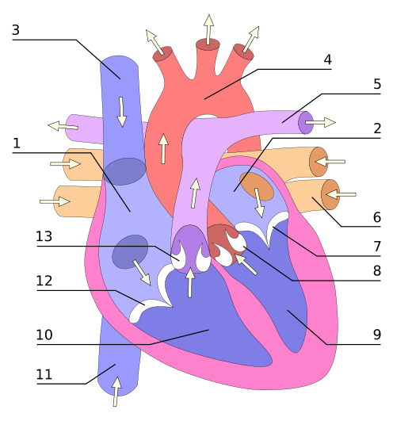

Using the diagram above, which of the following label the parts of the heart correctly:

|  |  |  |  |
| --- | --- | --- | --- |
| A | 12 = atrio-ventricular valve | 9 = left ventricle | 4 = aorta |
| B | 5 = aorta | 2 = right ventricle | 4 = right atrium |
| C | 7 = atrio-ventricular valve | 10 = left ventricle | 1 = right atrium |
| D | 3 = vena cava | 7 = semi-lunar valve | 9 = right ventricle |

10. The major driving force that moves blood in the veins is

a) active transport.

b) passive transport.

c) the closing of one-way valves.

d) skeletal muscle contractions.

11. Cardiac output can be reduced by

a) increasing heart rate.

b) decreasing stoke volume.

c) increasing the strength of ventricular contraction.

d) decreasing the concentration of oxygen in the blood.

The next THREE questions refer to the following diagram:

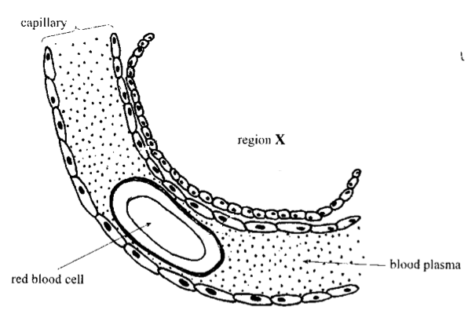

12. The region labelled X represents part of the

a) glomerulus.

b) alveolus.

c) villus.

d) cell.

13. The feature labelled red blood cell:

a) is called a Erythrocyte and carries the majority of the Carbondioxide in the blood in the form of carbaminohaemoglobin

b) is called a Erythrocyte and carries the majority of the Oxygen in the blood in the form of oxyhaemoglobin

c) is called a Thrombocyte and carries the majority of the Carbondioxide in the blood in the form of carbaminohaemoglobin

d) is called a Thrombocyte and carries the majority of the Oxygen in the blood in the form of oxyhaemoglobin

14. The concentration of carbon dioxide gas in the capillary is:

a) high and will move into region X.

b) low and will move into the blood plasma.

c) high and will move onto the red blood cell.

d) low and will move from the red blood cell to region X.

15. Which of the following is INCORRECT about blood clotting?

a) Platelets stick to any damaged surfaces of blood vessels, attracting more platelets

b) During clot retraction plasma is squeezed out of the clot

c) Fibrin are threads of insoluble proteins

d) Stuck platelets release vasoconstrictors

16. During the last stage of the cardiac cycle, which of the following events is occurring?

a) Atria relax while the ventricles contract; atrioventricular valves are closed while the semilunar valves are open.

b) Atria contract while the ventricles relax; atrioventricular valves are open while the semilunar valves are closed.

c) Atria and ventricles are relaxed; atrioventricular valves are open while the semilunar valves are closed.

d) Blood moves from the right ventricle into the aorta while blood moves from the left ventricle to the pulmonary artery.

17. The highest carbon dioxide concentrations will be found in blood

a) leaving the muscles.

b) entering the muscles.

c) leaving the lungs.

d) entering the lungs.

18. Asthma

a) is a result of widening of the bronchioles.

b) is a result of the contraction of smooth muscle in the bronchioles

c) is always caused by allergies.

d) is a result of lack of mucous in the airways.

19. A person with a higher metabolic rate would

a) have a higher breathing rate.

b) have a lower cardiac resting rate.

c) eat less.

d) produce less energy.

20. Cartilage rings:

a) form complete circles in the trachea.

b) prevent the oesophagus from collapsing.

c) maintain an open airway.

d) are found in the bronchioles.

**PART B: Short Answers (50 marks)**

[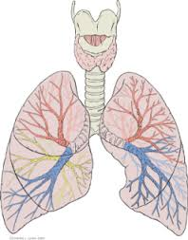](http://www.google.com.au/url?sa=i&rct=j&q=respiratory+system+diagram&source=images&cd=&cad=rja&uact=8&docid=34EVfcOo_mj2PM&tbnid=ayYPK4aqItfBcM:&ved=0CAUQjRw&url=http://www.medical-exam-essentials.com/human-respiratory-system.html&ei=nNQ8U8WjEsSllQXFr4DgCQ&psig=AFQjCNETRPXr3Aji6cYGSqeh7OFIPmIdmw&ust=1396581848908616)1. a) On the diagram above locate and name the respiratory surfaces where gas exchange occurs. (2 marks)

b) Explain two ways in which moisture is maintained on these surfaces (2 marks)

_______________________________________________________________________________________

_______________________________________________________________________________________

_______________________________________________________________________________________

_______________________________________________________________________________________

2. a) Explain the ways in which carbon dioxide is transported in the blood. Include the amount of carbon dioxide transported via each method. (3 marks)

_______________________________________________________________________________________

_______________________________________________________________________________________

_______________________________________________________________________________________

_______________________________________________________________________________________

_______________________________________________________________________________________

b) Explain how carbon dioxide moves from the blood, into the lungs and out of the body. (2 marks)

_______________________________________________________________________________________

_______________________________________________________________________________________

_______________________________________________________________________________________

_______________________________________________________________________________________

_______________________________________________________________________________________

|  |  |  |
| --- | --- | --- |
|  | INSPIRED AIR  (Total volume) | EXPIRED AIR  (Total volume) |
| Oxygen | 21% | 17% |
| Carbon Dioxide | 0.04% | 4% |
| Nitrogen and inert gases | 78% | 78% |
| Water vapour | Varies | Saturated |
| Temperature | Atmospheric | Body (37o C) |

3. Expired air and inspired air differ in composition. The following table gives an approximate comparison.

Explain the differences or the lack of difference between the inspired and expired values shown in the table. (5 marks)

_______________________________________________________________________________________

_______________________________________________________________________________________

_______________________________________________________________________________________

_______________________________________________________________________________________

_______________________________________________________________________________________

_______________________________________________________________________________________

_______________________________________________________________________________________

_______________________________________________________________________________________

_______________________________________________________________________________________

_______________________________________________________________________________________

4. Explain the difference between inspiratory reserve volume and expiratory reserve volume. Use a neat, labelled diagram to support your description. (3 marks)

_______________________________________________________________________________________

_______________________________________________________________________________________

_______________________________________________________________________________________

_______________________________________________________________________________________

_______________________________________________________________________________________

5.

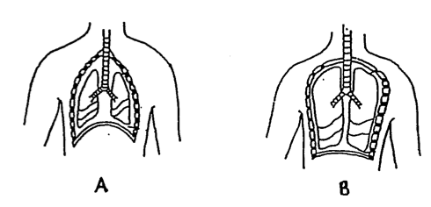

Which diagram indicates a person that is inhaling? Explain your reasoning. (3 marks)

_______________________________________________________________________________________

_______________________________________________________________________________________

_______________________________________________________________________________________

_______________________________________________________________________________________

6. The table below shows the main causes of death in Australia (2000).

|  |  |
| --- | --- |
| **Cause** | **%** |
| Cancer | 27.8 |
| Heart Disease | 20.7 |
| Stroke | 9.6 |
| Respiratory disease | 4.6 |
| Accidents | 4.0 |
| Diabetes | 2.3 |
| Influenza & Pneumonia | 2.3 |
| Other(s) | 28.6 |
| **Total (percentage)** | **100.0** |

a) List TWO factors that could contribute to heart disease being the second major cause of death in Australia.

(2 marks)

_______________________________________________________________________________________

_______________________________________________________________________________________

_______________________________________________________________________________________

b) What is the difference between a heart attack and stroke? (2 marks)

_______________________________________________________________________________________

_______________________________________________________________________________________

_______________________________________________________________________________________

_______________________________________________________________________________________

7. The diagram below shows a capillary and the surrounding cells it supplies

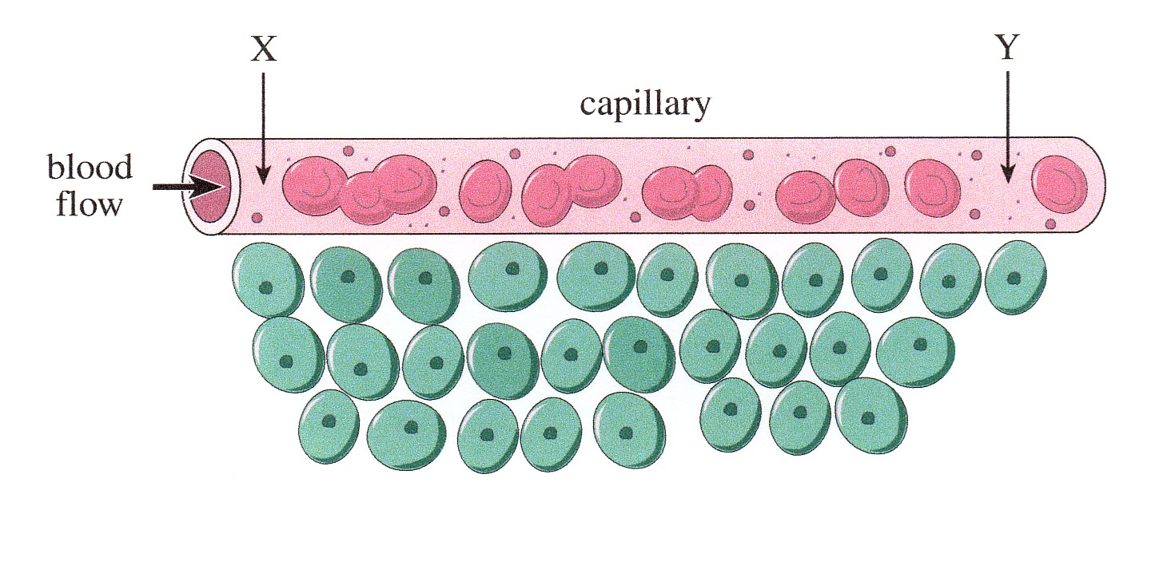

CIRCLE the CORRECT term in each of the following statements.

As blood flows through the capillary from Point X to Point Y: (6 marks)

i) the amount of glucose in the blood increases/decreases.

ii) the amount of oxygen in the blood increases/decreases.

iii) the amount of carbon dioxide in the blood increases/decreases.

iv) the amount of oxyhaemoglobin in the blood increases/decreases.

v) the amount of carbaminohaemoglobin in the blood increases/decreases.

vi) the pressure in the vessel increases/decreases.

8. During a heart dissection, you notice that ‘one side’ of the heart is much thicker that the other side (see photo below). Your group members say this is because the thick side pumps more blood as the heart is a double pump.

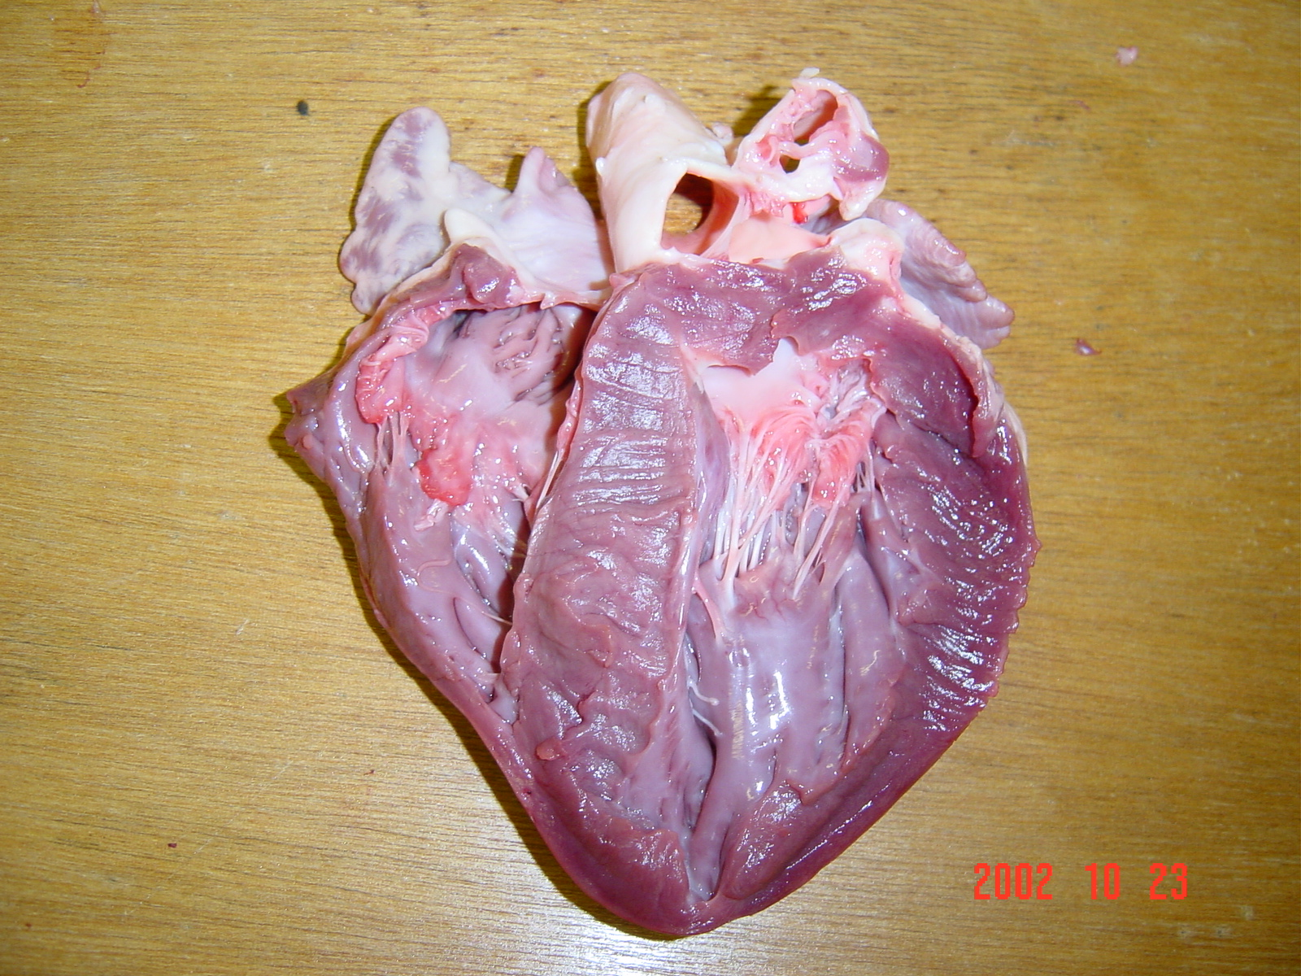

Thicker

Side.

a) What is the ‘thick part’ of the heart structure that is being examined? (1 mark)

_______________________________________________________________________________________

b) Are your fellow group members correct for stating that ‘*this side is thicker as it pumps more blood’*?

Explain. (2 marks)

_______________________________________________________________________________________

_______________________________________________________________________________________

_______________________________________________________________________________________

7. The graph below shows the pulse rate and the output of blood from the left side of the heart before, during and after a period of exercise.



a) What was the output of blood from the left side of the heart when exercise ended? (1 mark)

_______________________________________________________________________________________

b) What was the difference between the maximum and minimum pulse rates? (1 mark)

_______________________________________________________________________________________

c) What was the maximum cardiac output attained during the 22 minutes that the observations continued?

(1 mark)

_______________________________________________________________________________________

THE END

**Year 11 Human Biological Science**

**Respiratory and Circulatory Systems**

Name: ____________________________________________

Multiple Choice Answer Sheet

1. A B C D 11. A B C D

2. A B C D 12. A B C D

3. A B C D 13. A B C D

4. A B C D 14. A B C D

5. A B C D 15. A B C D

6. A B C D 16. A B C D

7. A B C D 17. A B C D

8. A B C D 18. A B C D

9. A B C D 19. A B C D

10. A B C D 20. A B C D

**PART B: Short Answers (50 marks)**

[](http://www.google.com.au/url?sa=i&rct=j&q=respiratory+system+diagram&source=images&cd=&cad=rja&uact=8&docid=34EVfcOo_mj2PM&tbnid=ayYPK4aqItfBcM:&ved=0CAUQjRw&url=http://www.medical-exam-essentials.com/human-respiratory-system.html&ei=nNQ8U8WjEsSllQXFr4DgCQ&psig=AFQjCNETRPXr3Aji6cYGSqeh7OFIPmIdmw&ust=1396581848908616)1. a) On the diagram above locate and name the respiratory surfaces where gas exchange occurs. (2 marks)

b) Explain two ways in which moisture is maintained on these surfaces (2 marks)

1. lungs deep inside body – reduce evaporation

2. moist surface in respiratory system – humidify air

2. a) Explain the ways in which carbon dioxide is transported in the blood. Include the amount of carbon dioxide transported via each method. (3 marks)

7-8% dissolved in plasma

22% carbanimo haemoglobin

70% bicarbonate ions

b) Explain how carbon dioxide moves from the blood, into the lungs and out of the body. (2 marks)

diffusion from high

|  |  |  |
| --- | --- | --- |
|  | INSPIRED AIR  (Total volume) | EXPIRED AIR  (Total volume) |
| Oxygen | 21% | 17% |
| Carbon Dioxide | 0.04% | 4% |
| Nitrogen and inert gases | 78% | 78% |
| Water vapour | Varies | Saturated |
| Temperature | Atmospheric | Body (37o C) |

3. Expired air and inspired air differ in composition. The following table gives an approximate comparison.

Explain the differences or the lack of difference between the inspired and expired values shown in the table. (5 marks)

1 mark for each

Difference (or lack of) explained no marks for just listing

4. Explain the difference between inspiratory reserve volume and expiratory reserve volume. Use a neat, labelled diagram to support your description. (3 marks)

- 1 for each missing

Tidal volume and both reserves drawn on appropriate picture

Appropriate description for inspiratory and expiratory which highlights difference

No marks if no diagram

5.



Which diagram indicates a person that is inhaling? Explain your reasoning. (3 marks)

B – 1 mark

1 mark for any 2 reasons

6. The table below shows the main causes of death in Australia (2000).

|  |  |
| --- | --- |
| **Cause** | **%** |
| Cancer | 27.8 |
| Heart Disease | 20.7 |
| Stroke | 9.6 |
| Respiratory disease | 4.6 |
| Accidents | 4.0 |
| Diabetes | 2.3 |
| Influenza & Pneumonia | 2.3 |
| Other(s) | 28.6 |
| **Total (percentage)** | **100.0** |

a) List TWO factors that could contribute to heart disease being the second major cause of death in Australia.

(2 marks)

Any 2 – 1 mark each

b) What is the difference between a heart attack and stroke? (2 marks)

Heart attack – blood flow to part of heart reduced/stopped causing damage 1 mark

Stroke – blood flow to part of brain reduced/stopped causing damaged 1 mark

7. The diagram below shows a capillary and the surrounding cells it supplies



CIRCLE the CORRECT term in each of the following statements.

As blood flows through the capillary from Point X to Point Y: (6 marks)

i) the amount of glucose in the blood increases/decreases.

ii) the amount of oxygen in the blood increases/decreases.

iii) the amount of carbon dioxide in the blood increases/decreases.

iv) the amount of oxyhaemoglobin in the blood increases/decreases.

v) the amount of carbaminohaemoglobin in the blood increases/decreases.

vi) the pressure in the vessel increases/decreases.

8. During a heart dissection, you notice that ‘one side’ of the heart is much thicker that the other side (see photo below). Your group members say this is because the thick side pumps more blood as the heart is a double pump.



Thicker

Side.

a) What is the ‘thick part’ of the heart structure that is being examined? (1 mark)

Left Ventricle

b) Are your fellow group members correct for stating that ‘*this side is thicker as it pumps more blood’*?

Explain. (2 marks)

No 1 mark

Appropriate explanation 1 mark

7. The graph below shows the pulse rate and the output of blood from the left side of the heart before, during and after a period of exercise.



a) What was the output of blood from the left side of the heart when exercise ended? (1 mark)

16ml/min

b) What was the difference between the maximum and minimum pulse rates? (1 mark)

148-70 = 78bpm

c) What was the maximum cardiac output attained during the 22 minutes that the observations continued?

(1 mark)

17ml/min

THE END